**50. Spring Security - Adding Logout Support**

**Add Logout button**:

Now we add logout button to our home page. When user click the logout button, it will clear the user's session and redirect the user back to the login page.

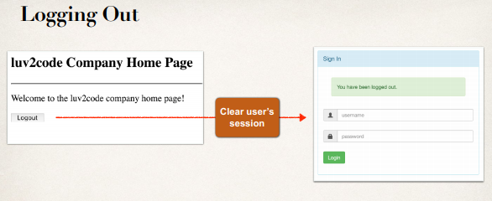

**Development Process (Step-by-Step)**:

1. Add logout support to Spring Security Configuration
2. Add logout button to JSP page
3. Update login form to display “**logged out**” message

**Step 1: Add Logout support to Spring Security Configuration**:

@Override

//Configure security of web paths in application, login, logout etc

**protected** **void** configure(HttpSecurity http) **throws** Exception {

//Restrict access based on the HttpServletRequest

http.authorizeRequests()

//Any request to the app must be authenticated (i.e logged in)

.anyRequest().authenticated()

.and()

//We are customizing the form login process

.formLogin()

// Show our custom form at the request mapping "/showMyLoginPage"

.loginPage("/showMyLoginPage")

// Login form should POST data to this URL for processing (check

user id and password)

.loginProcessingUrl("/authenticateTheUser")

// Allow everyone to see login page. No need to be logged in.

.permitAll()

// add logout support for this given application

.and()

.logout().permitAll();

}

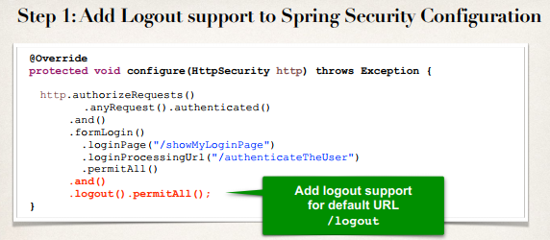

**Step-2: Add logout button to JSP page**:

* Send data to default logout URL: /logout
  + By default, must use **POST** method
* Logout URL will be handled by Spring Security Filters
* We get it for free … no coding required

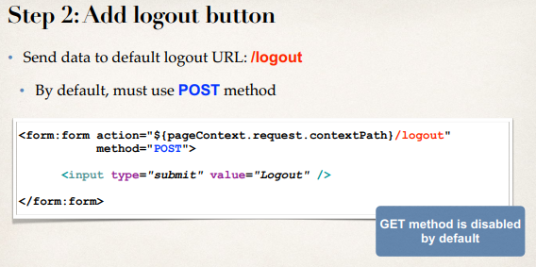

<!-- Add a logout button -->

<form:form action=*"*${pageContext.request.contextPath}*/logout"*

method=*"POST"*>

<input type=*"submit"* value=*"Logout"*>

</form:form>

**Logout process**:

1. When a logout is processed, by default Spring Security will …
2. Invalidate user’s HTTP session and remove session cookies, etc.
3. Send user back to our login page
4. Append a logout parameter: ?logout

**Step 3: Update login form to display "logged out" message**:

* Update login form
  + Check the logout parameter
  + If logout parameter exists, show “logged out” message

**Code**:

<!-- Check for logout -->

<c:if test=*"*${param.logout != null}*"*>

<div class=*"alert alert-success col-xs-offset-1 col-xs-10"*>

You have been logged out.

</div>

</c:if>

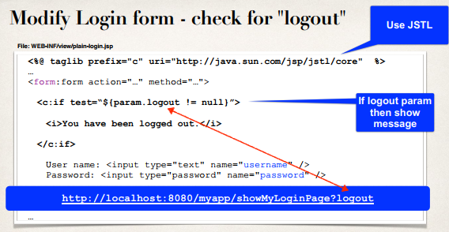

50. Spring Security - Adding Logout Support